If Face is configured for Login, then the following screen will display

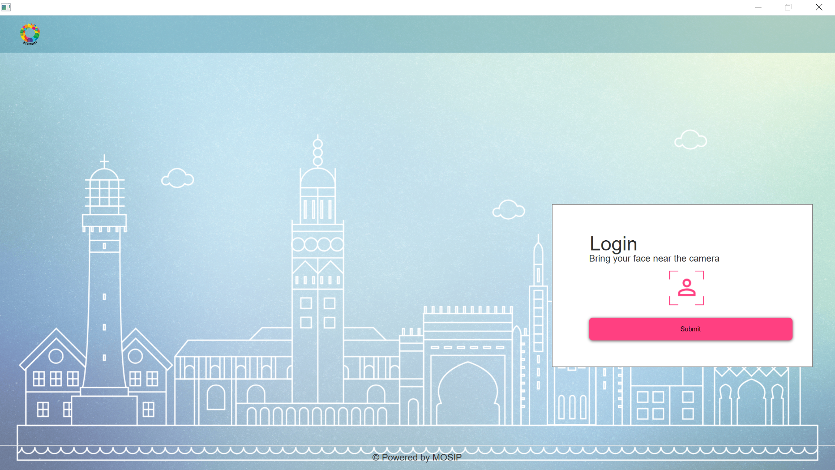

If Face is not configured and Iris is the only mode of Login, then the following message will be displayed.

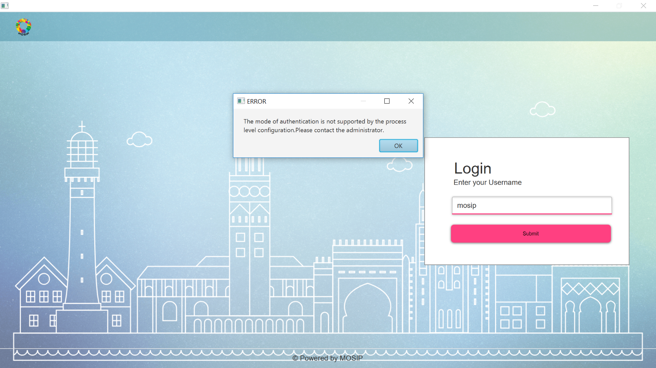

If Face configuration is enabled, then the Face capture will look as follows

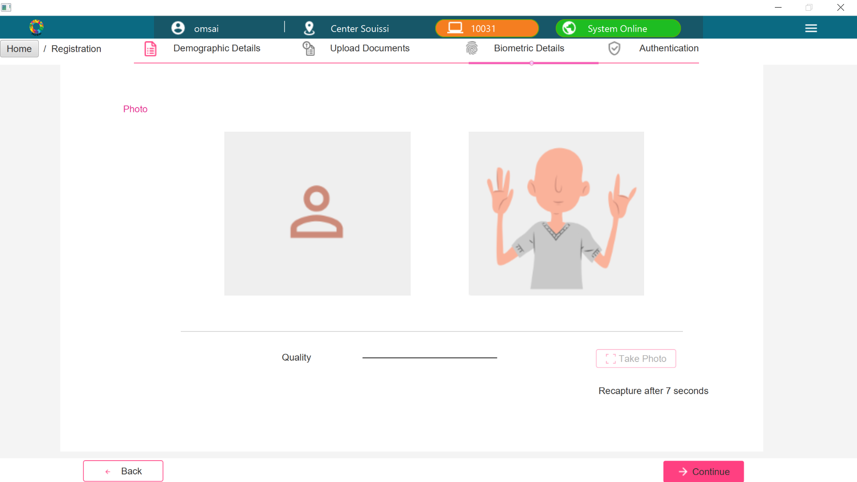

If Face configuration is disabled, then above screen will get skipped

If Face configuration is enabled, then the preview screen will look as follows

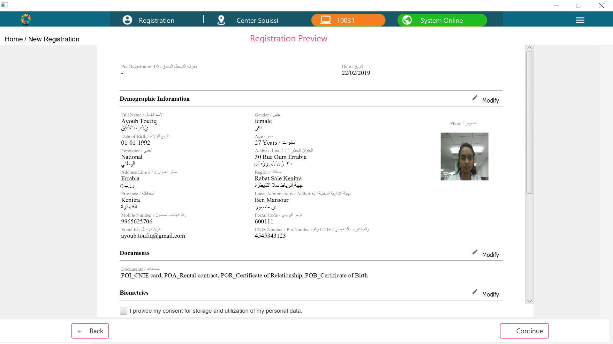

If Face configuration is disabled, then the preview screen will look as follows

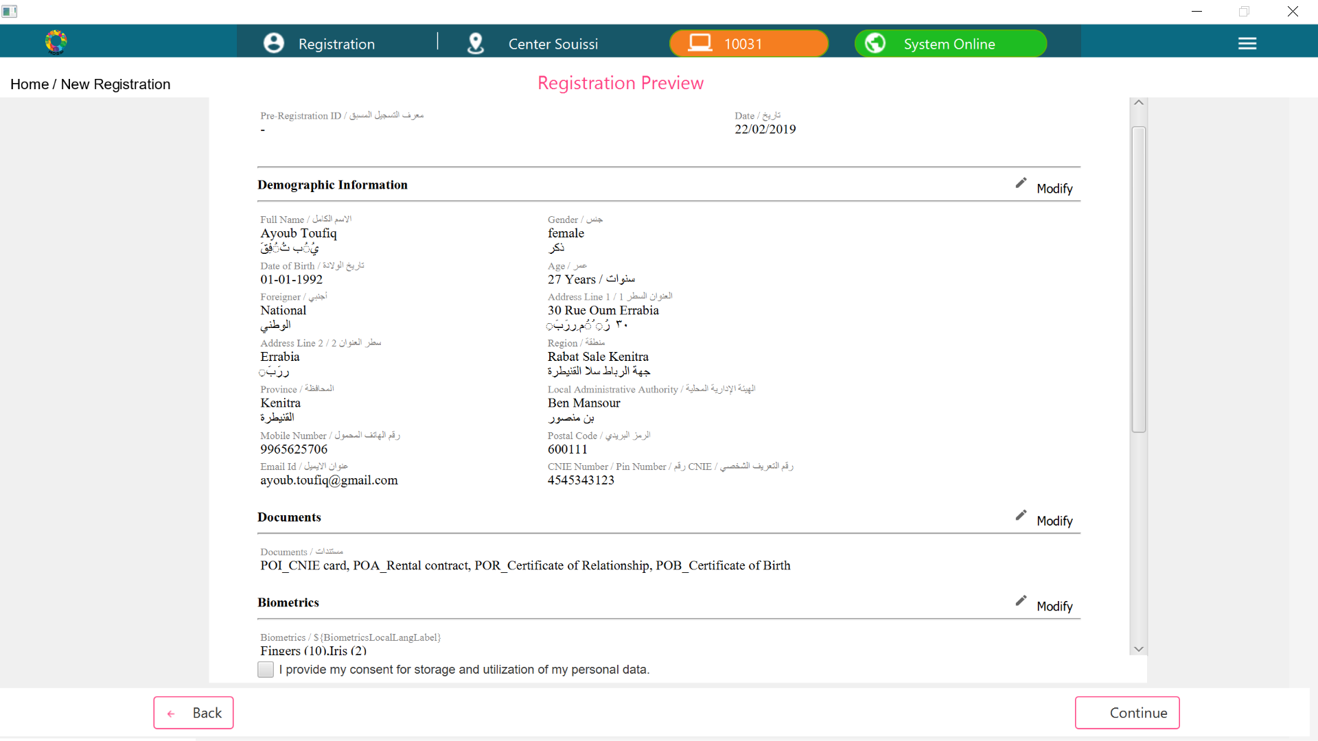

If Face configuration is enabled, then the Operator Authentication screen will look as follows

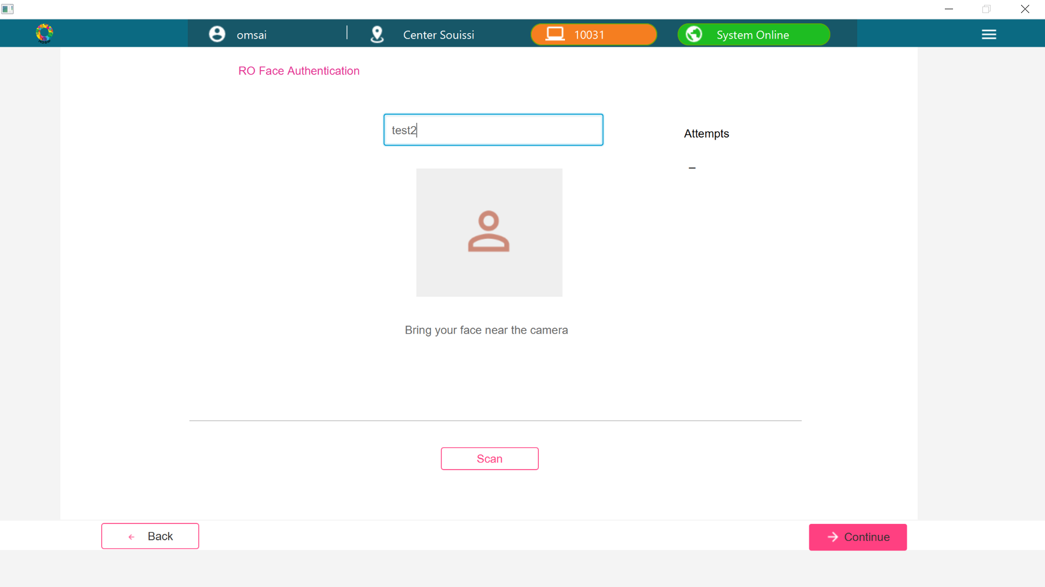

If Face configuration is disabled, then the Operator Authentication screen will look as follows

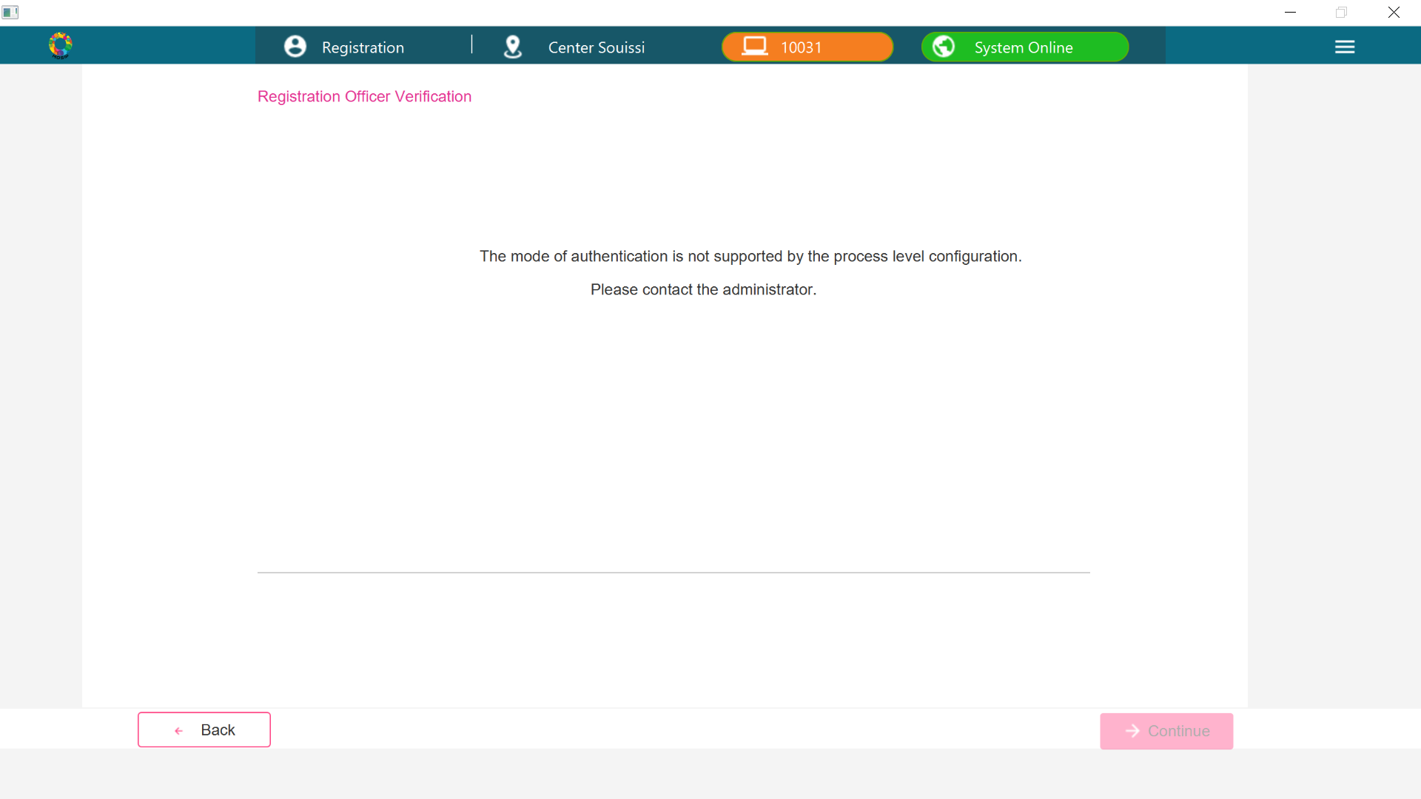

If Face configuration is enabled, then the Supervisor Authentication screen will look as follows

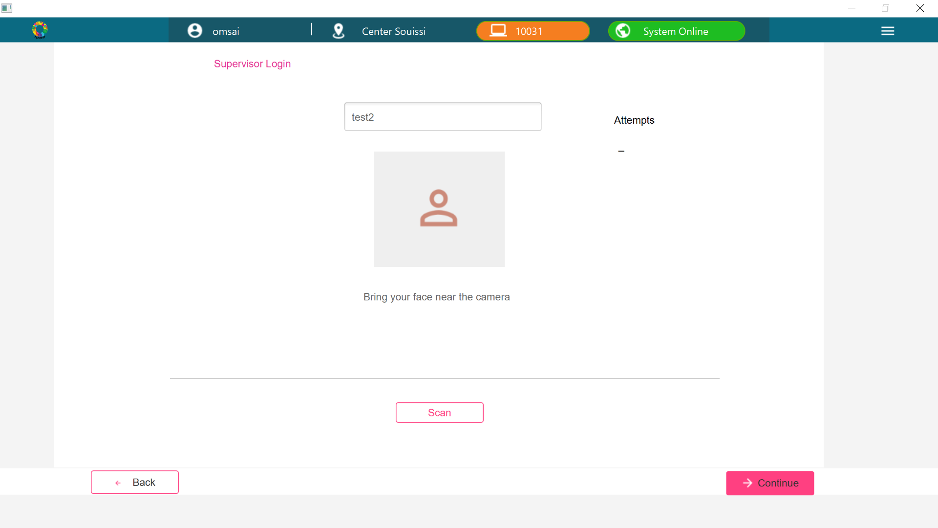

If Face configuration is disabled, then the Supervisor Authentication screen will look as follows

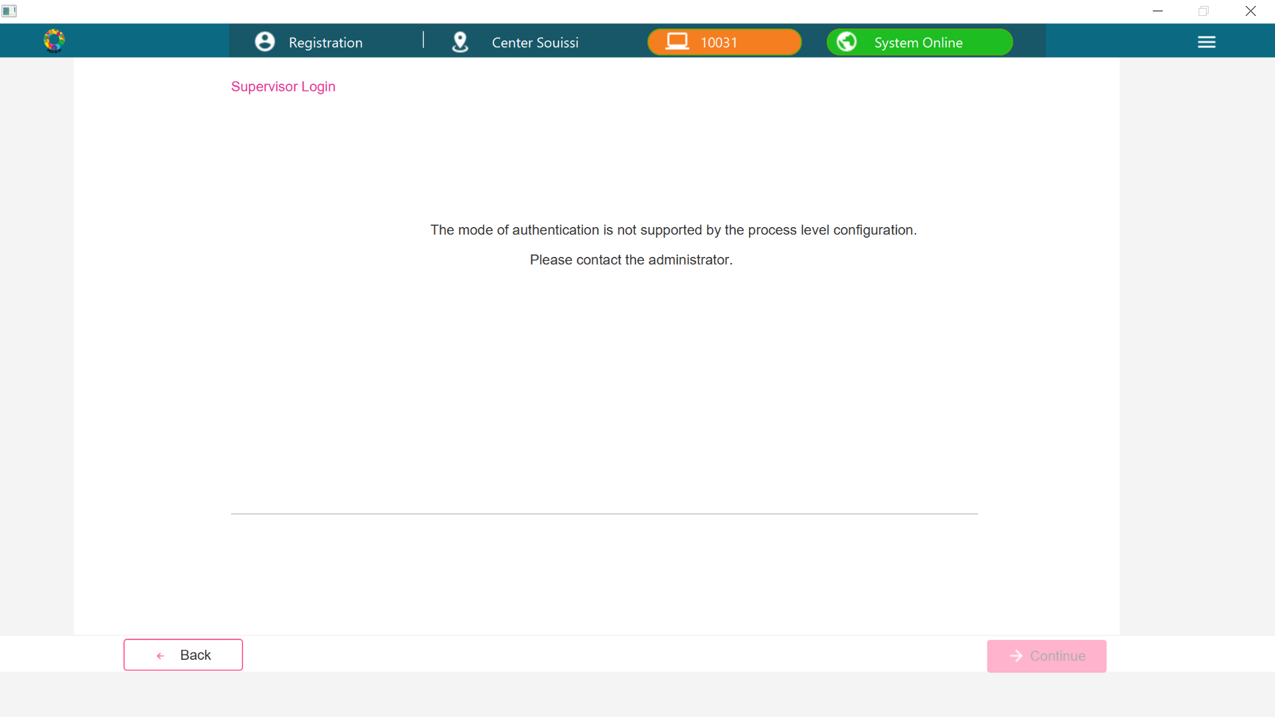

If Face configuration is enabled, then the Acknowledgement screen will look as follows

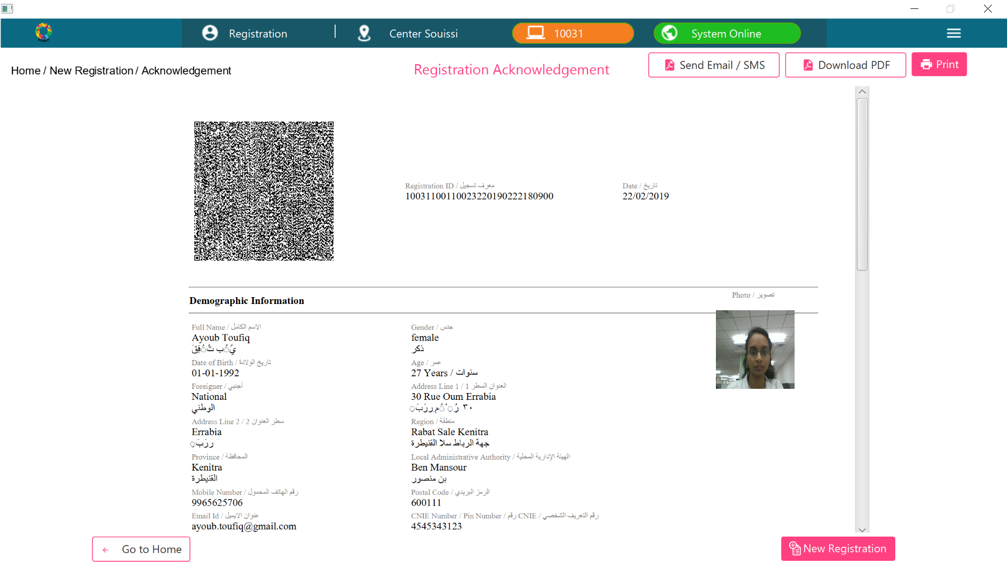

If Face configuration is disabled, then the Acknowledgement screen will look as follows

